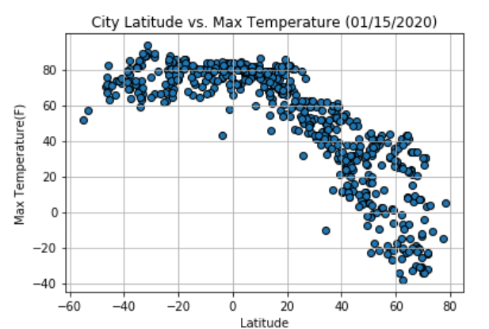

There is a strong correlation between temperature and latitude. As latitude goes up max temperature goes down.

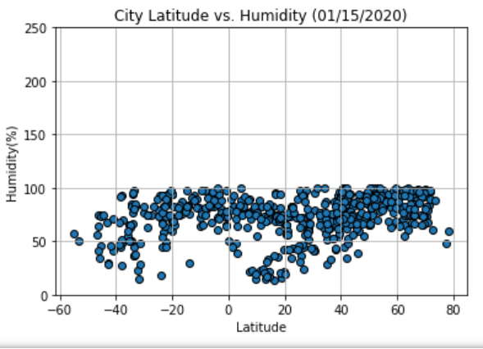

There is no strong correlation between Latitude and humidity.

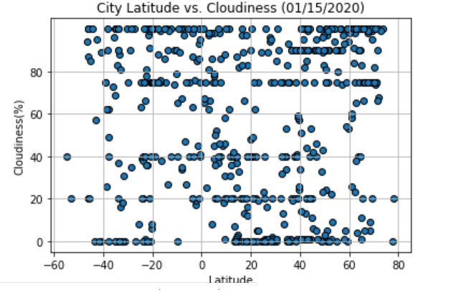

There is no strong correlation between City Latitude and Cloudiness

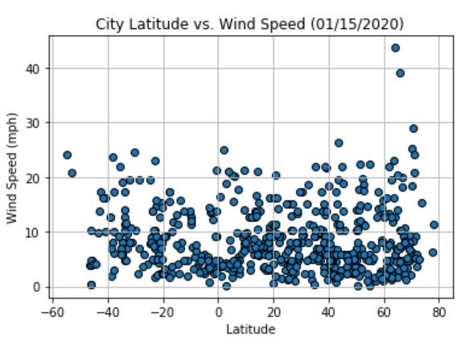

There is no strong correlation between City Latitude and Cloudiness

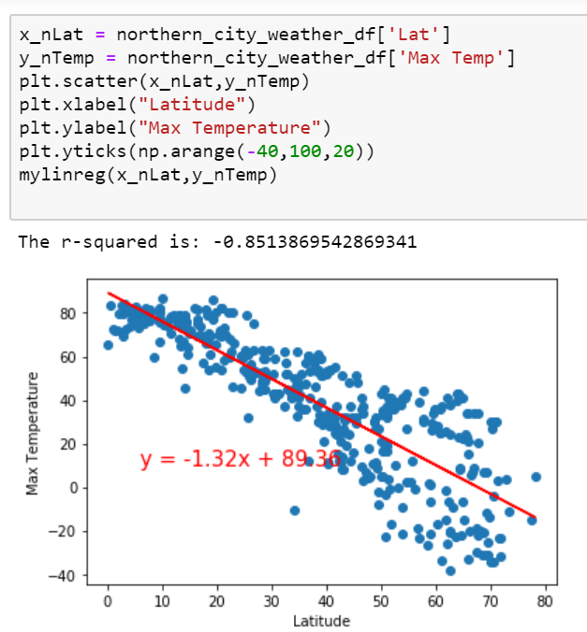

For the Northern hemisphere (latitude >0) max temperature goes down as Latitude increases

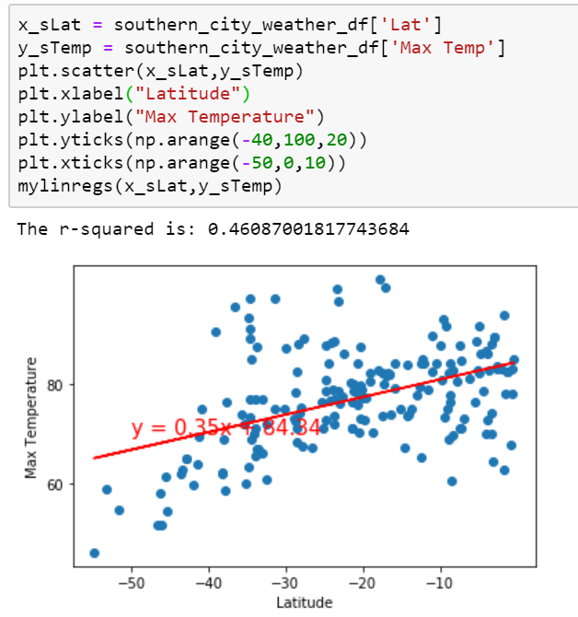

For the Southern hemisphere (latitude <0) max temperature goes up as Latitude gets closer to zero. Although, correlation is less than .5.

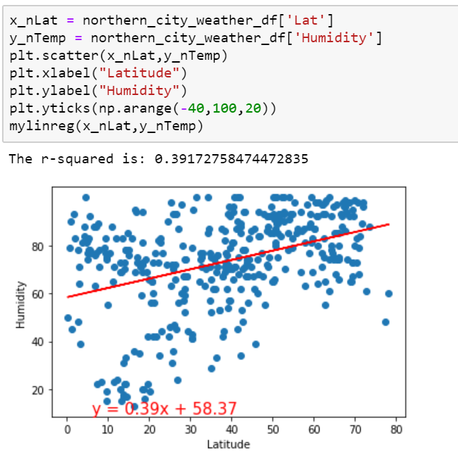

There is a weak positive correlation between Humidity and Latitude for the northern hemisphere.

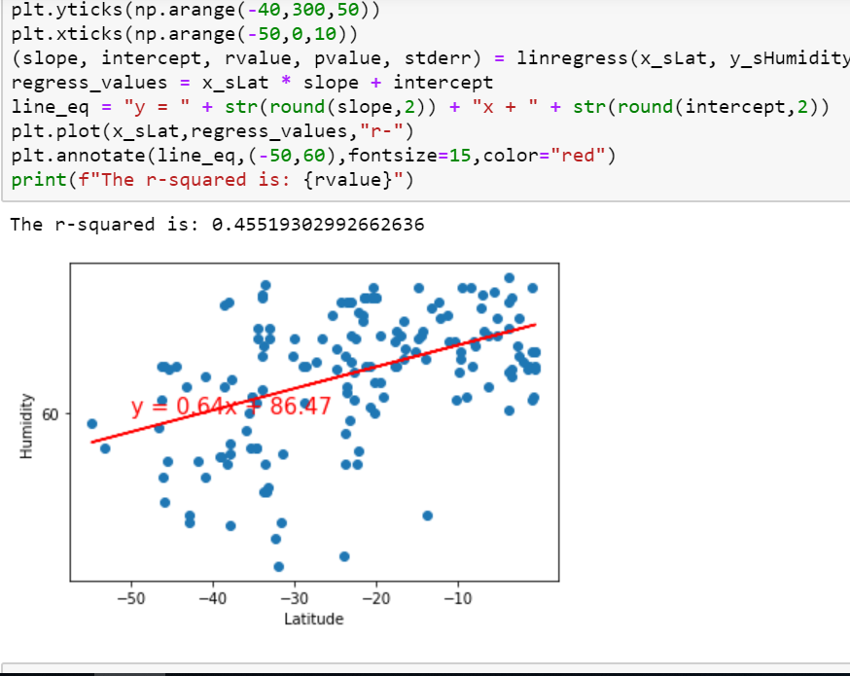

No strong correlationship but graph shows there is slightly a positive correlation between Latitude and Humidity.

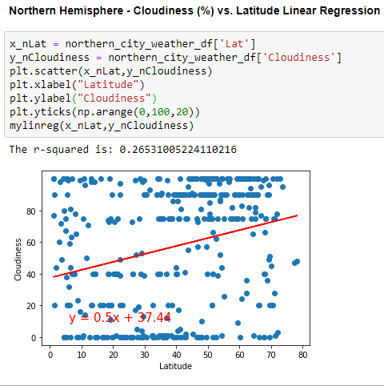

No strong correlation n between cloudiness and latitude on the northern hemisphere.

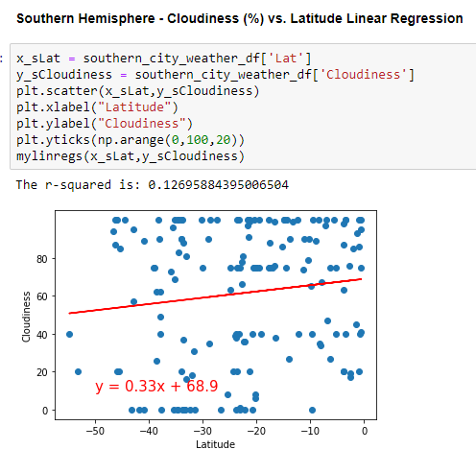

No strong correlation n between cloudiness and latitude on the southern hemisphere.

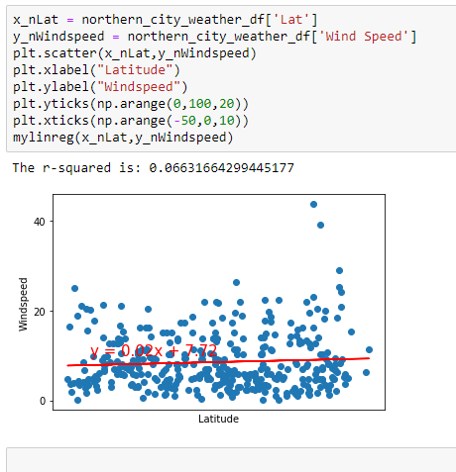

Very low correlation between latitude and wind speed for the northern hemisphere.

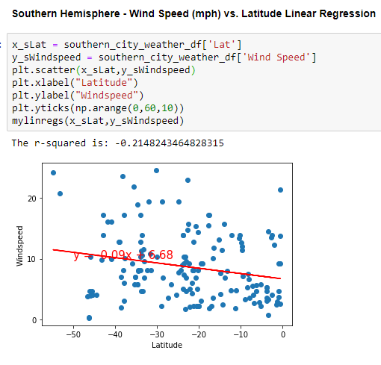

Very low correlation between latitude and wind speed for the southern hemisphere.